**Facets properties setup:**

Registration Steps (Inside Admin Facets => admin.pzb):

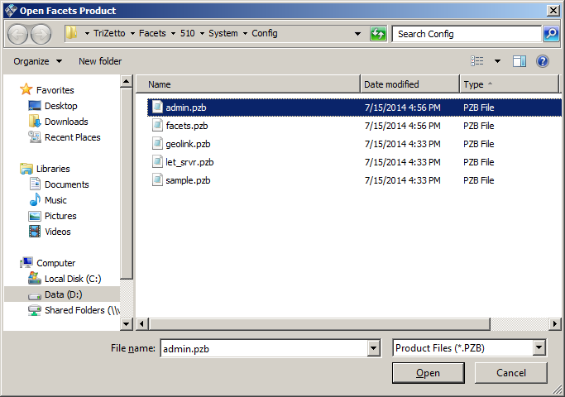

* **Step 1: Add Library (CER_APLB_LIBRARY table)**
  + - Open “Library/Module” application in “Application” application group
    - Go to “Library” segment
    - Edit.. Add.. Section
    - Fill the “Add Library” dialog and click OK
    - Omit location if an embedded extension is located in Facets \bin directory

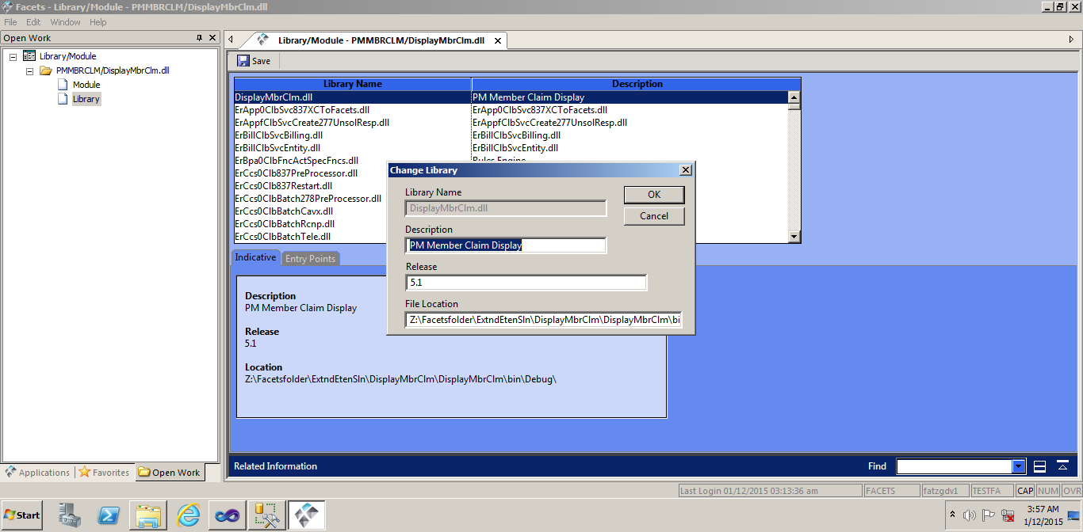

* **Step 2: Add Entry Point (CER_APLE_ENTITY table)**
  + - In the same “Library/Module” application, same “Library” segment, have the Library entered in Step 1 highlighted
    - Click on “Entry Points” tab
    - Select Edit.. Add.. Subsection
    - Fill the “Add Library Entry Point” dialog
      * Entry Point is Namespace.Classname from your project
      * Type is TEEF (**T**riZetto **E**mbedded **E**xtension **F**orm)

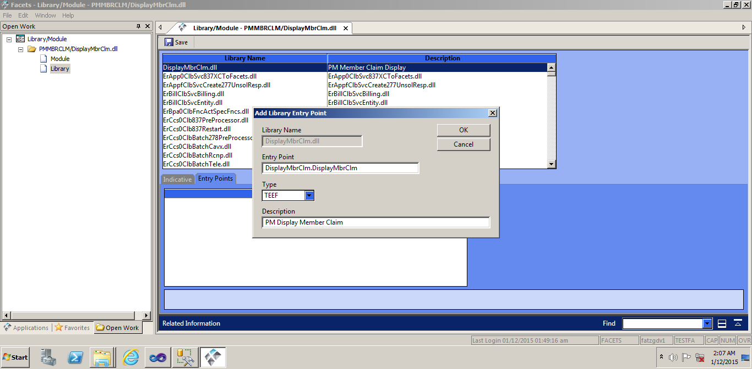

* **Step 3: Add Module (CER_APMD_MODULE table)**
  + - In the same “Library/Module” application
    - Go to “Module” segment
    - Select Edit.. Add
    - Fill the “Add Module” dialog and click OK
      * The Module ID must not duplicate any of the existing Facets modules; for example EExx (such as EEC1).
    - Add the extension Description
    - In the “Available Libraries-Entry Points” grid, select the entry point created in step 2 (red diamond confirms the selection).
    - Save the record (e.g. File.. Save).

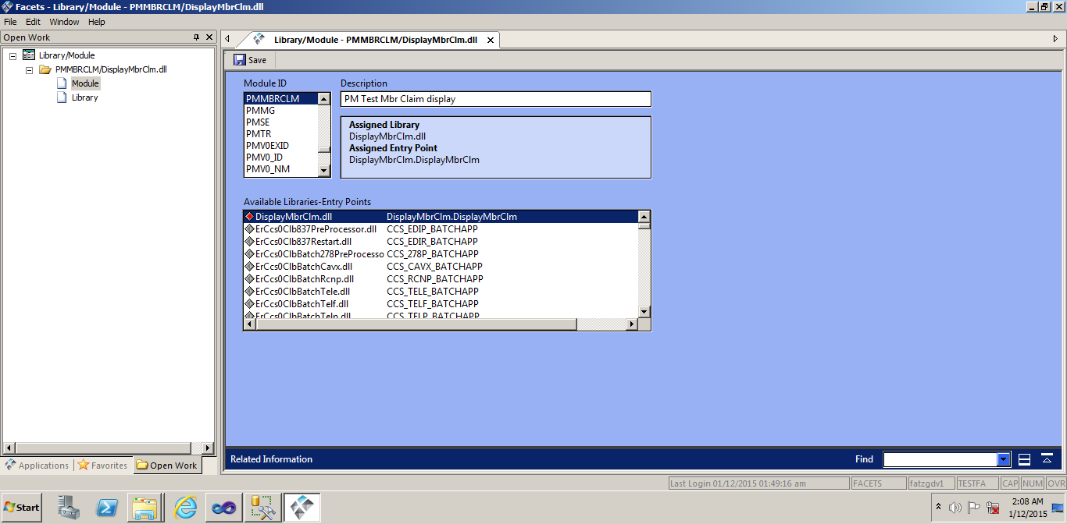

* **Step 4: Add Component (CER_SYCO_COMPONENT table)**
  + - Open “Component Definition” application in “System Data” application group
    - Enter Component ID, which must not duplicate any of the existing Facets components; for example EExx (such as EEC1).
    - Select Component Type of “Related Info Applet” (RTP0)
      * You may also choose “Extension Panel” (EEP0)
    - Click on “Create New Record”
    - Fill the “Component Description” and “Default Display Label” fields
    - In “Configuration” tab, select Module ID to be the same as the one created in Step 3.

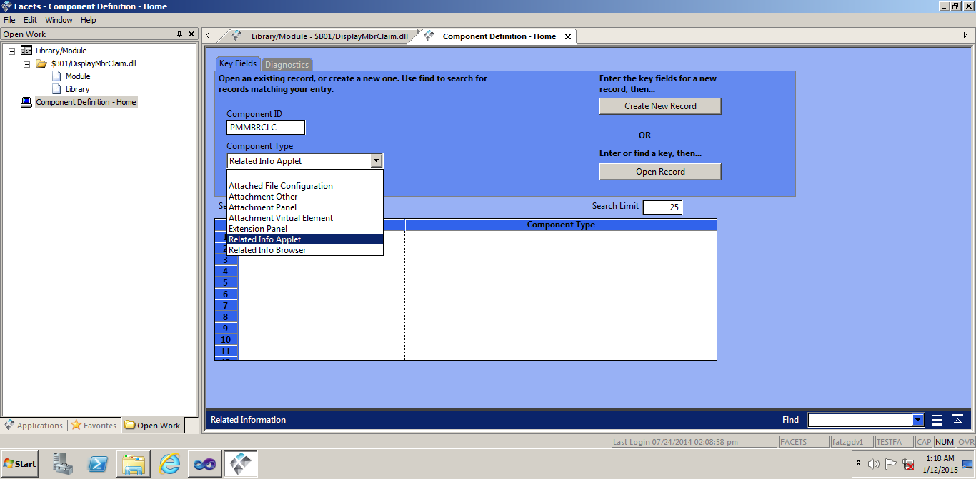

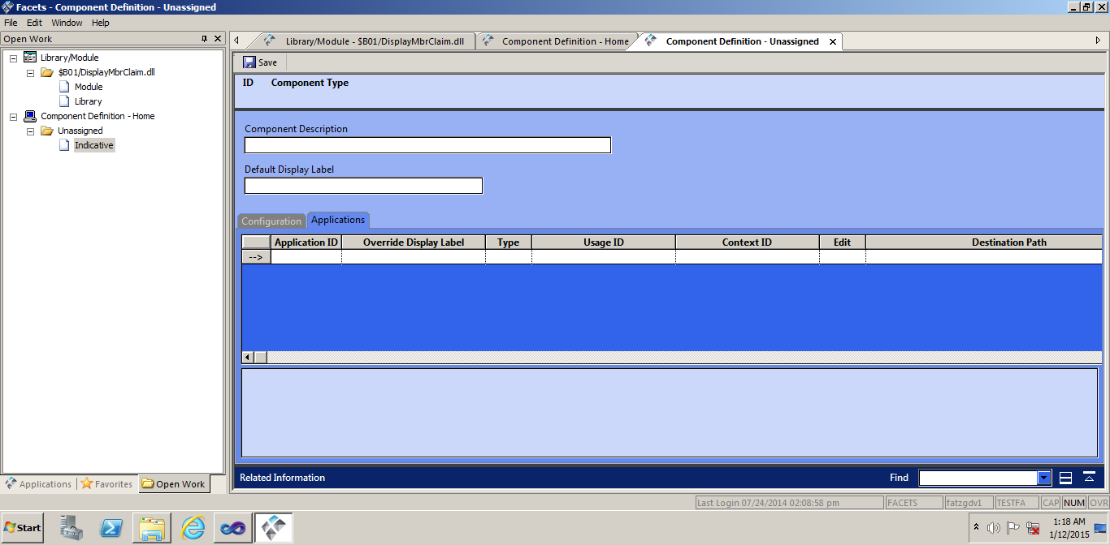

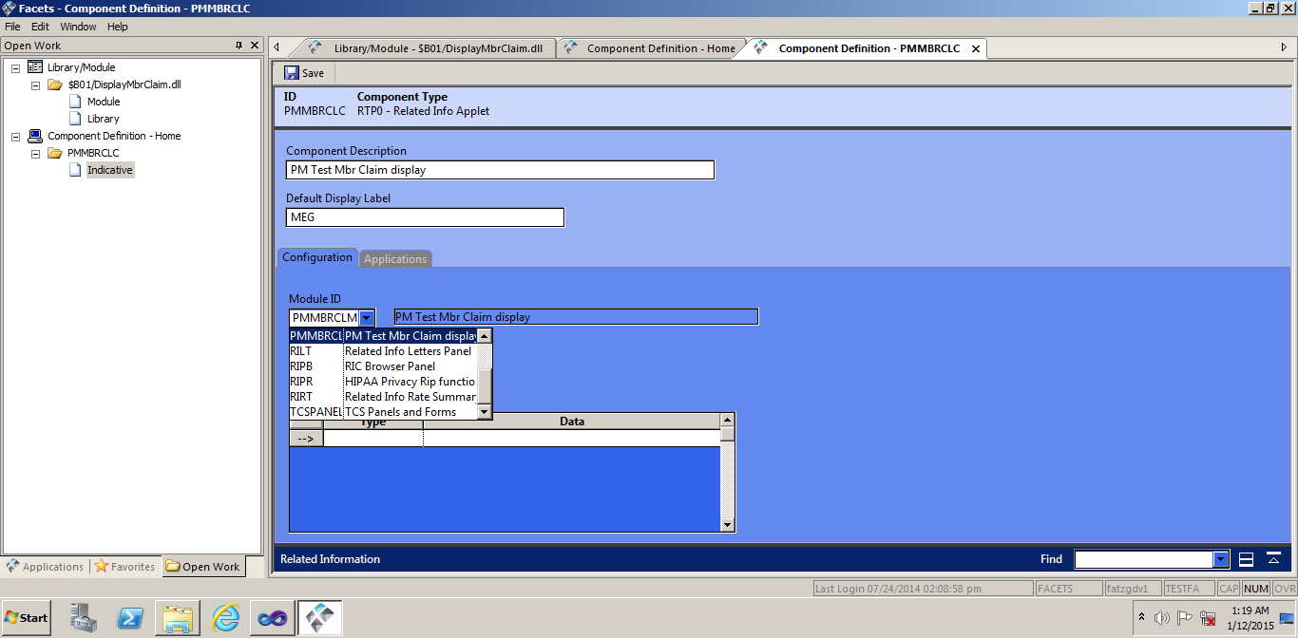

* **Step 5: Associate Component with one or more Facets Applications (CER_APCO_COMPONENT table)**
  + - Application ID represent Facets application that will host the embedded extension
    - “Override Display Label” allows the extension to have unique title in the Related Information Area for each application
    - Type is always “RP11 - Related Info Panel, Configurable”
      * If the Component Type is “EEP0”, you may select “EP11 Extension Panel, Configurable”
    - Save the record (e.g. File.. Save).

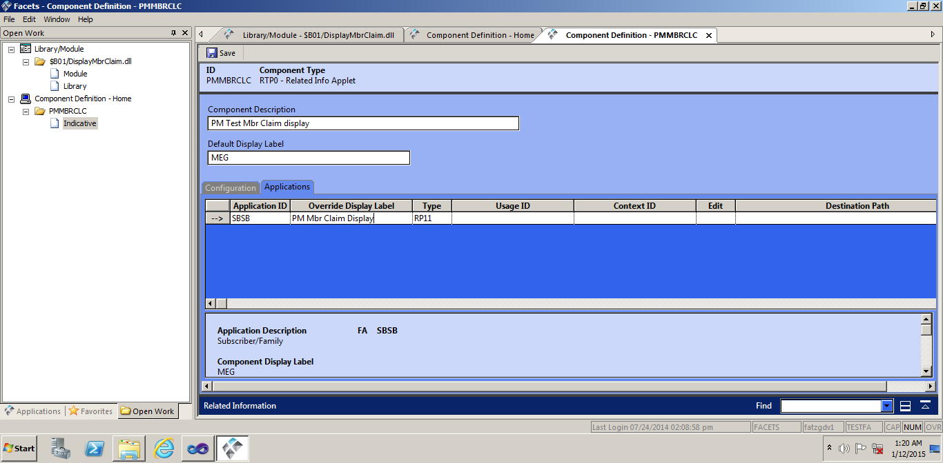

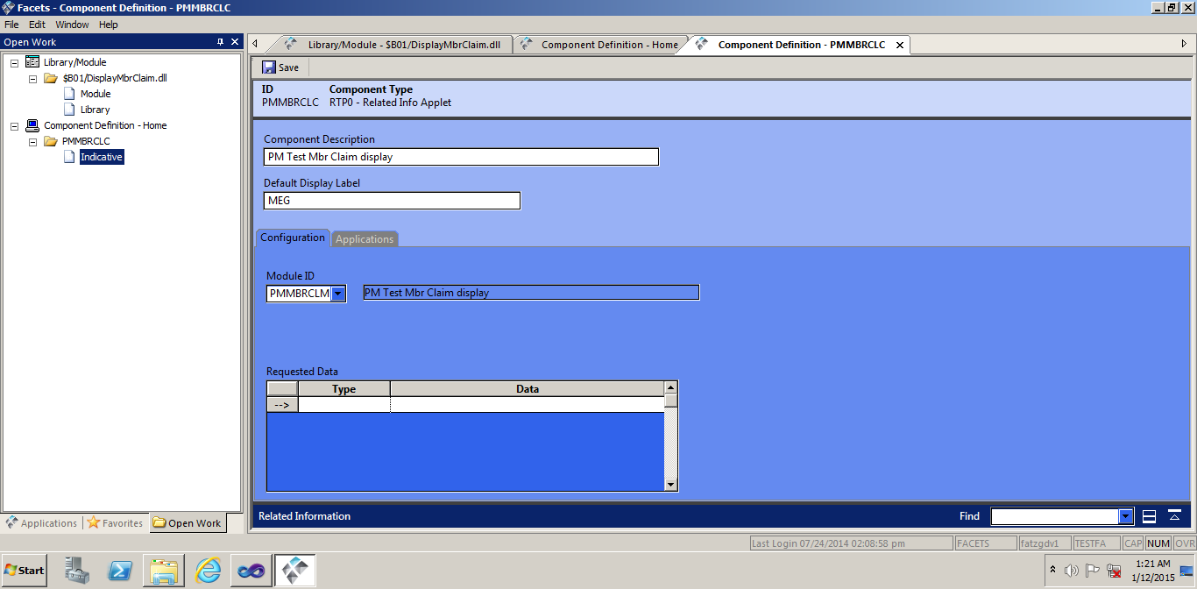

Inserting Grid in CS file(Visual Studio)



**Visual Studio Properties setup:**

Coding Process – Creating new class:

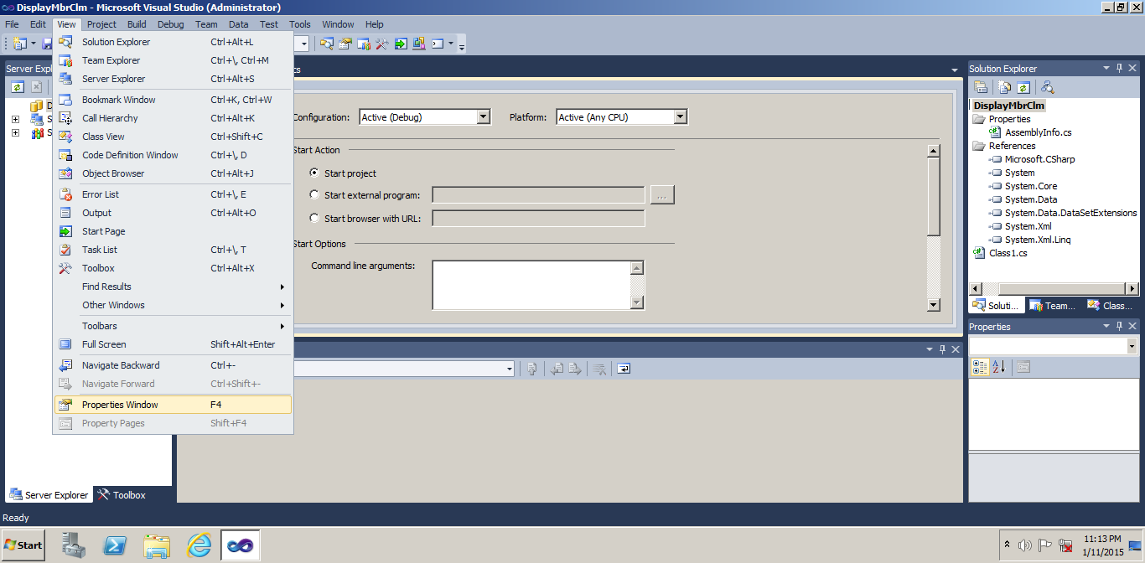

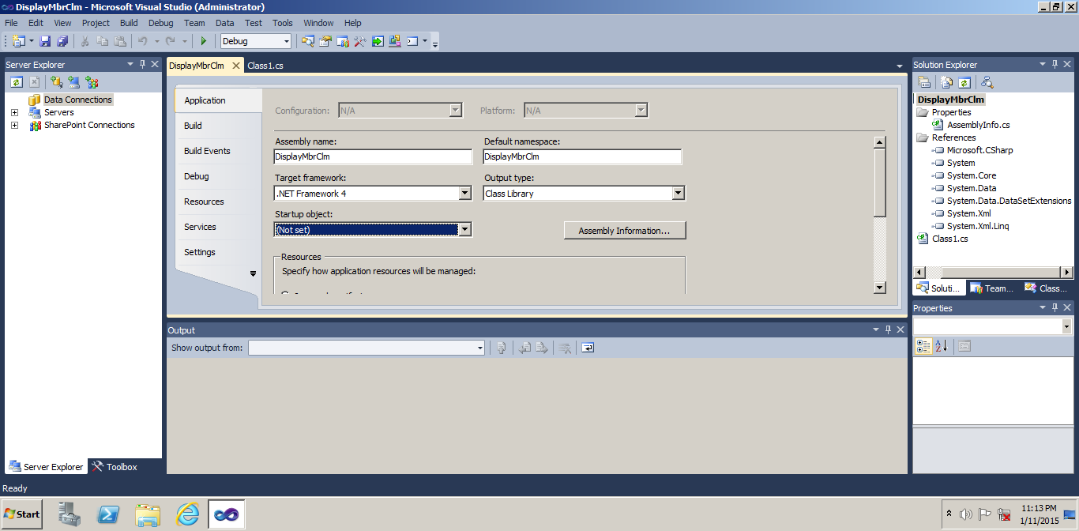

* **Set Project Properties to facilitate debugging:**
  + - While in the Project Property Pages, navigate to “Debugging”
    - In “Start Action” section:
      * Check “Start external program” option on
      * Set “Start Application” to location of Facets client executable e.g. D:\TriZetto\Facets\510\System\Bin\ceraexe0510.exe

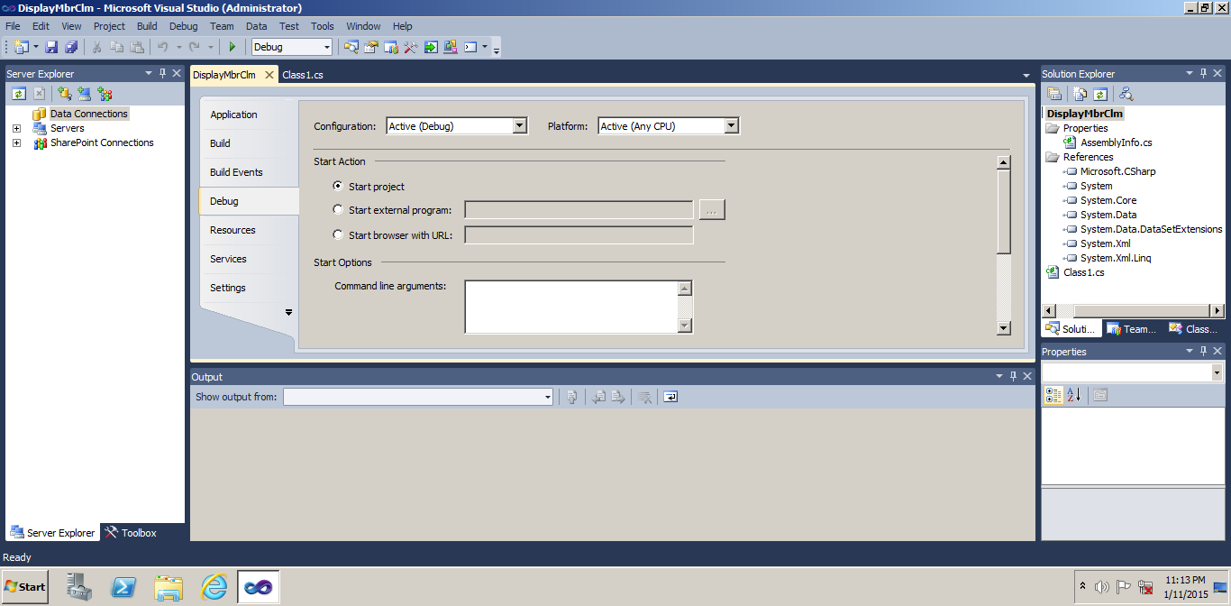

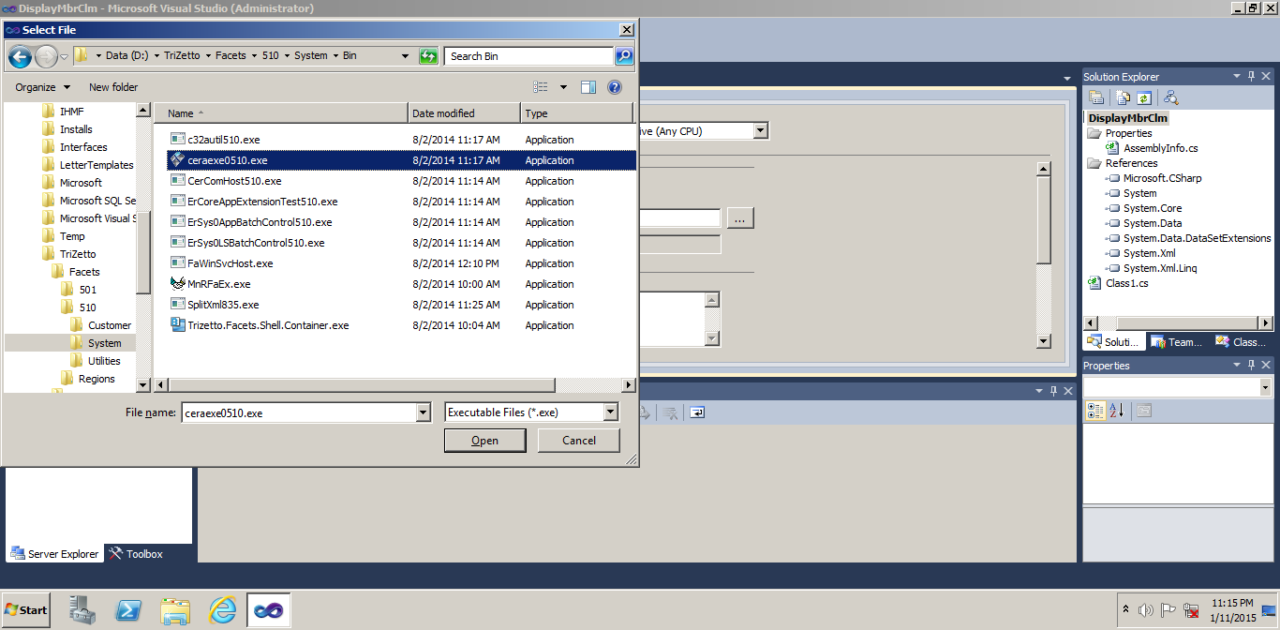

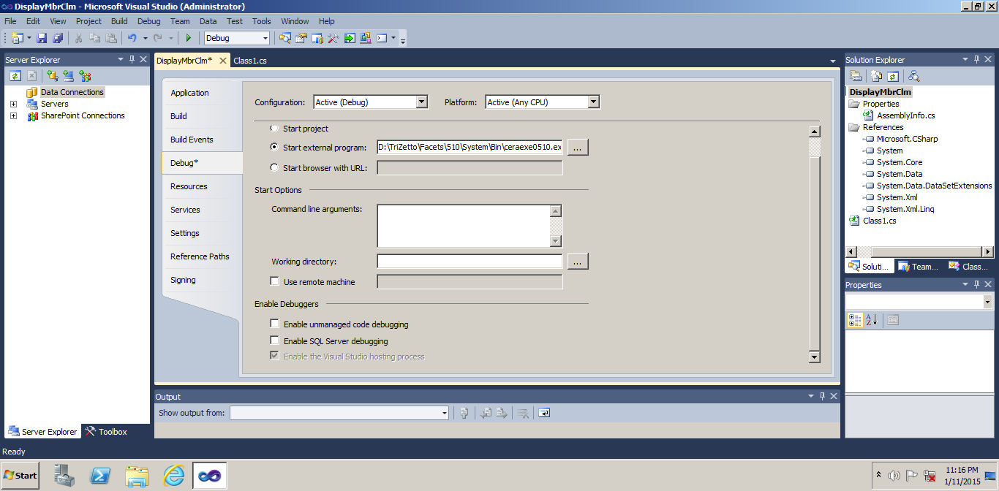

* **Add Reference to Facets Base Control**
  + - Right-click on References in Solution Explorer; select “Add Reference”
    - Click Browse...
    - Browse to Facets bin directory,   
      e.g. D:\TriZetto\Facets\510\System\Bin\
    - Select FacetsBaseControl501.dll

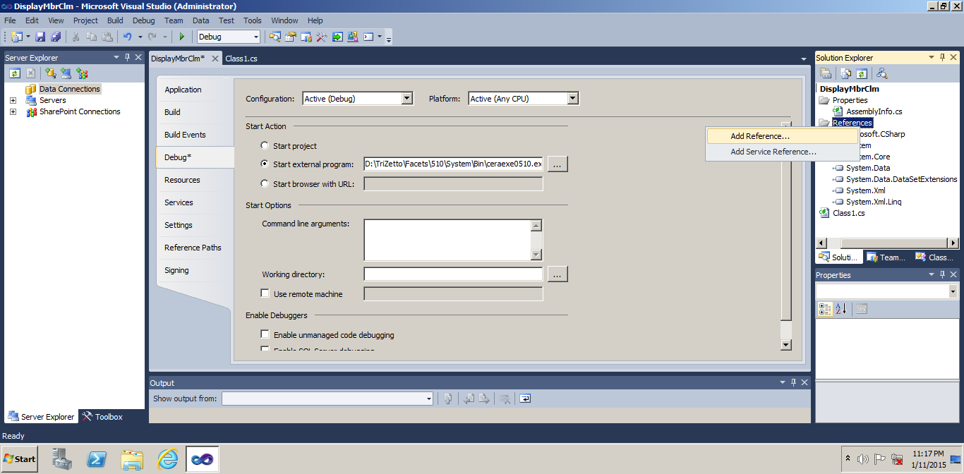

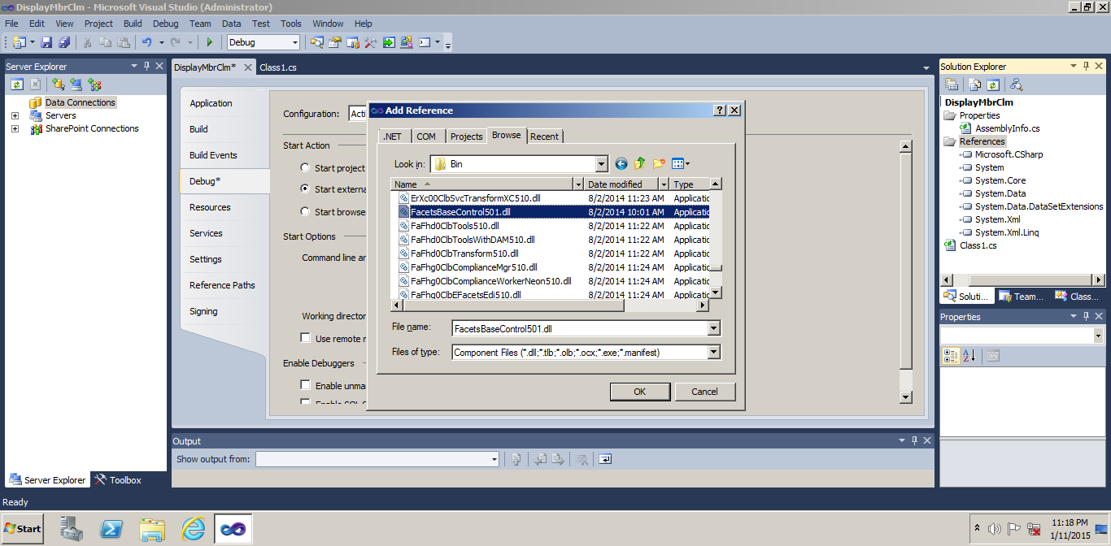

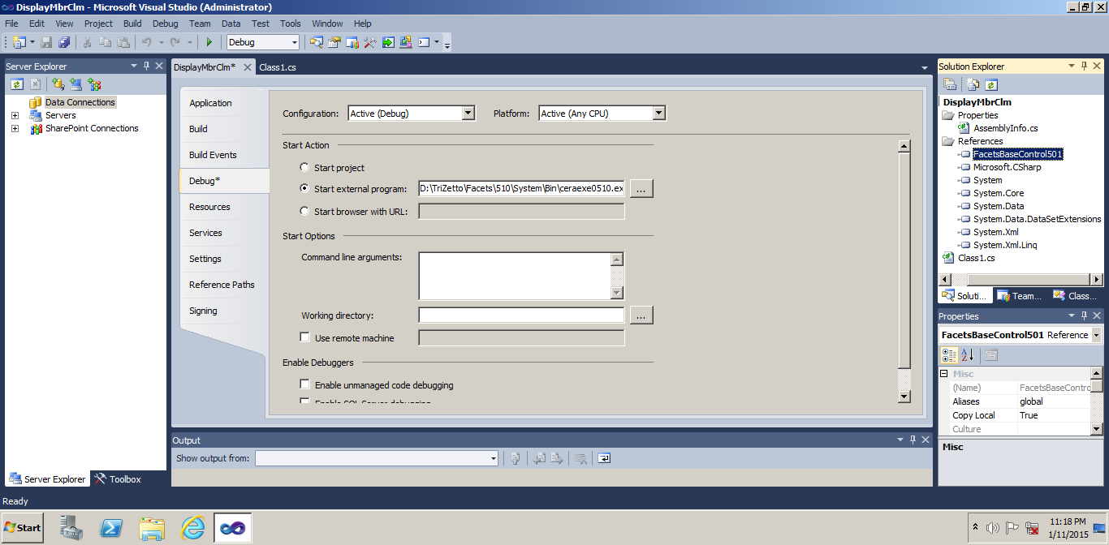

* **Delete class1.class available in the References in Solution Explorer**
* **Add a new Inherited User Control**
  + Specify a meaningful name

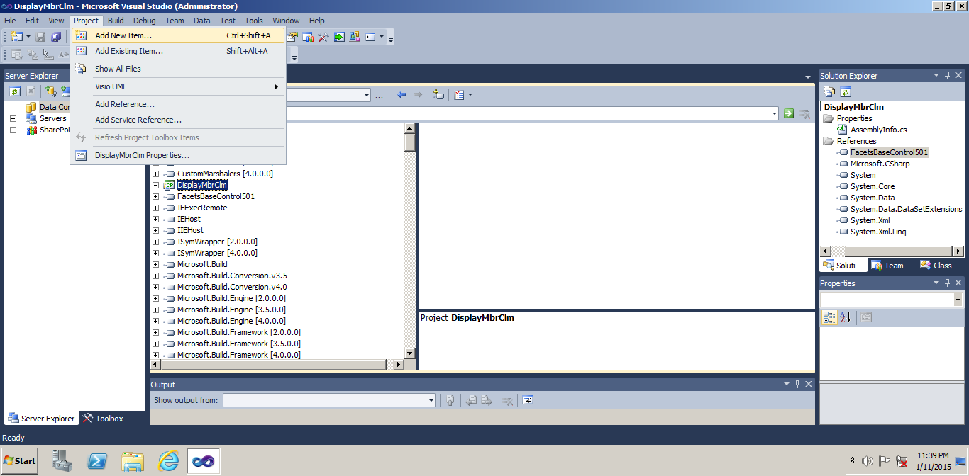



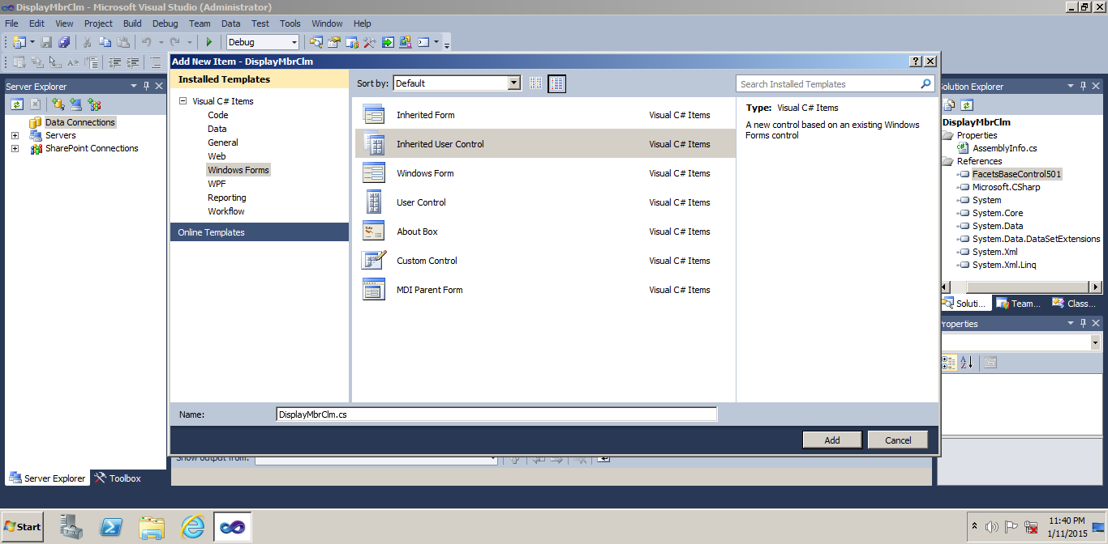

* **Add a new Inherited User Control**
  + - Use the Inheritance Picker to browse to the Facets bin directory and specify FacetsBaseControl501.dll

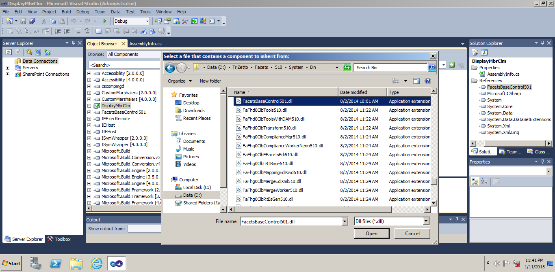



* **Add graphical components to your extension control, as they need to appear in the Related Information Area.**
* **In the below example, Datagridview control is placed in the CS**

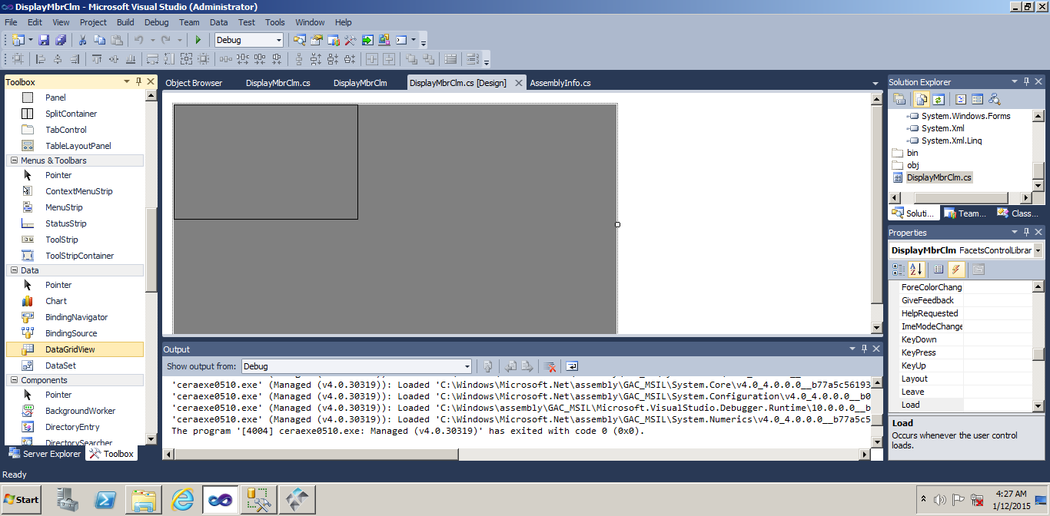

* Add events from the right hand side of the Properties window

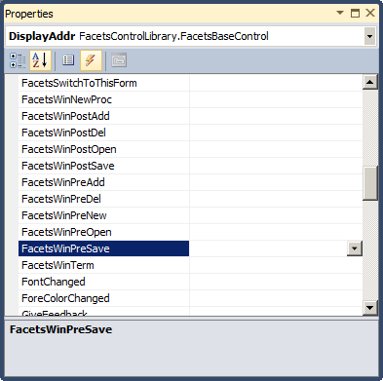

* **Once the code is completed, build and then execute directly in FACETS or go through Debug Mode from Visual Studio**
* Execution (Inside Normal Facets => facets.pzb):

Execution through Debug Mode: Debug Menu=> Start Debugging or Click on Start Debugging icon

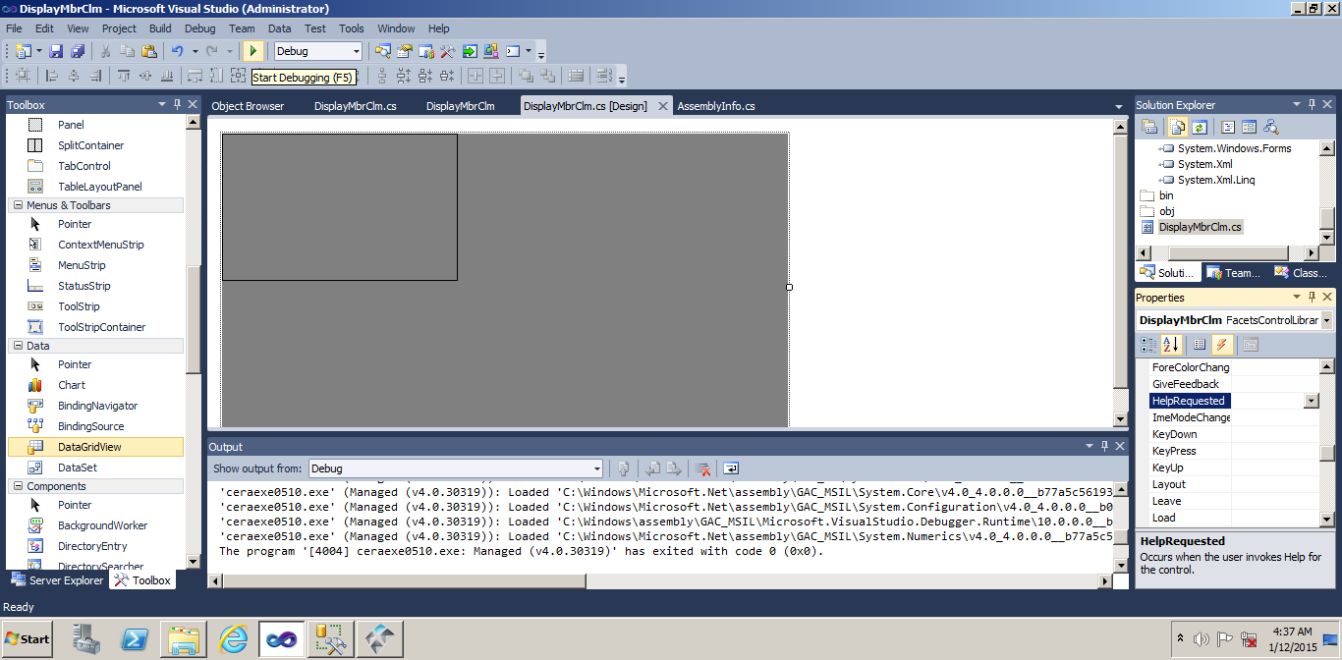

Facets will be opened Automatically, Need to choose correct Database

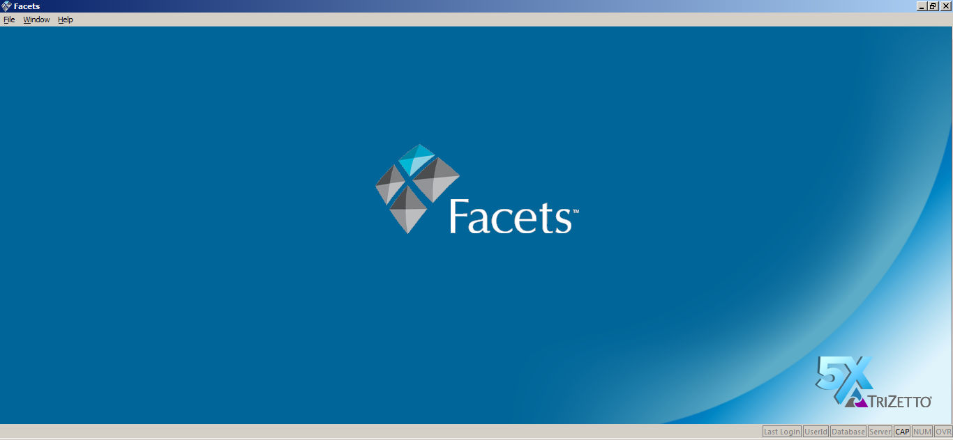

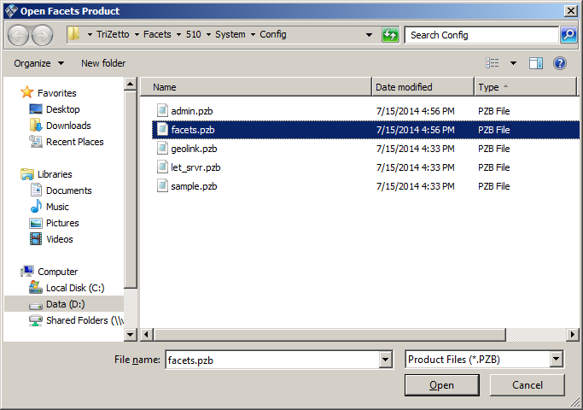

Open the group to get the records, once the code is executed, records will be displayed in the grid when the newly created Extension name is selected from the Related Information section area.

